November Newsletter ( Pre School)
Welcome back! We hope you had an enjoyable halfterm break and are ready for the busy run up the Christmas! There is a lot happening over the next few weeks in school so please take the time to read the following important information.
November Topics: Day and Night/Space
How can you help?:
- Talk to your child about space and some of the different planets.
- Talk about bedtime and morning routines: what things we need to do before bed/in morning?
- Read a bedtime story with your child.
- Observe the sun setting/rising with your child and the moon coming out at night.
- Develop your child’s understanding of ‘w’ questions ie. Why do we need to brush our teeth?
When do we go to bed? What planet do we live on? Where does the sun go when it is dark? Who flies into space?

Reporting
As part of our school development plan we have been focusing on observation and assessment of children and how we can make these more meaningful and use the information we gather on your child to inform and improve our practice. This will ensure we are meeting the needs of individuals. We are really excited about how this area is developing and feel that we are much more in tune with the needs of individual children. Due to these changes we will no longer be issuing are Autumn and Spring Achievements to parents but will instead be focusing on intense tracking of children at different periods throughout the year. This will help us build a better picture of your child’s strengths and needs and we will be able to share this information with you at our next parents’ meeting.
However, you are welcome to discuss your child’s progress at any time with the class teacher. Please contact school to arrange an appointment.

Dental Hygiene Programme:
All children will be receiving a toothbrush and toothpaste as part of the school dental programme. We will be focusing on dental hygiene in school and encourage you to use these to support and reinforce this at home.

Getting Ready to Learn Programme:
We will be beginning our ‘Getting ready to learn’ programme this month. The aim of the programme is to support and enable parents to engage and take an active role in their child’s learning through fun activities, resources and ideas. We are delighted to say that our programme will be beginning on Friday 17th November with the launch of our Big Bedtime Read.
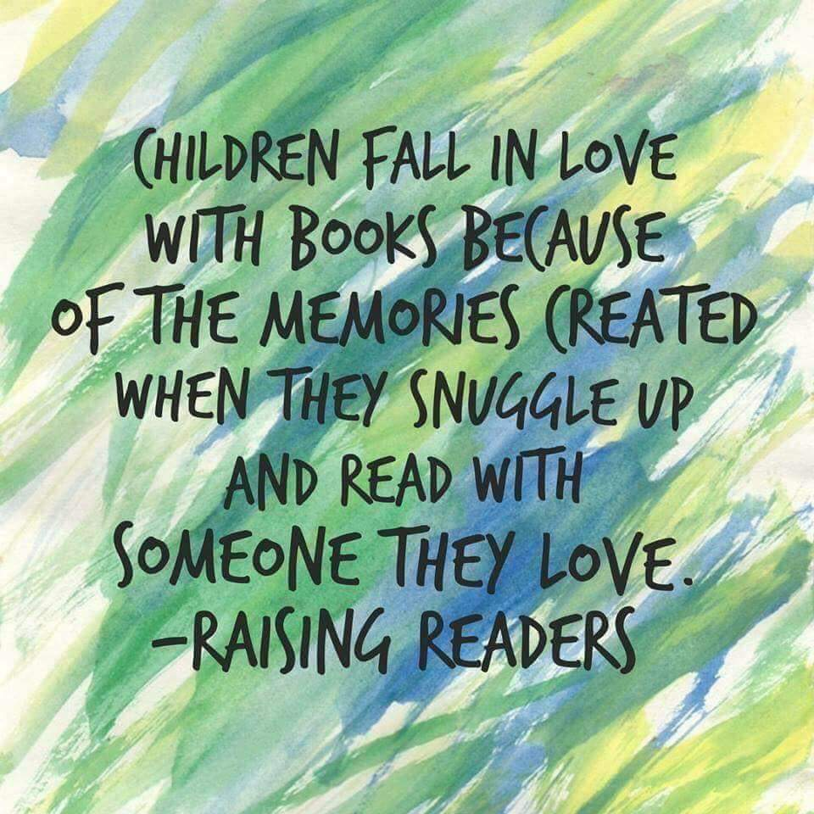
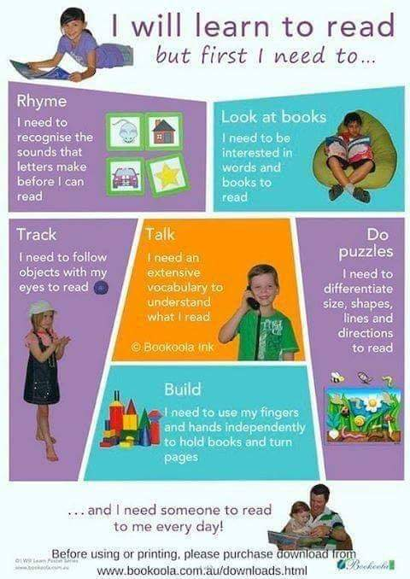

Children will be invited to come to school in their PJs for a special day of fun and they will then receive a book bag with home with them with 5 books in it. We would encourage you to read these books with your child as often as they like, but particularly at bedtime. This is a lovely opportunity to set aside a little bit of time just for you and your child to enjoy and be together. You will be asked to return the bag on Friday 15th December and your child can choose their favourite book from the bag to keep at home.
This is part of this project there is a dedicated parent area on the website that you can visit for activities and resources.
How do I access the Parent Area?
1. Visit the GRTL Website Homepage at www.gettingreadytolearn.co.uk
2. On the top left, select ‘Sign In/Create Account’
3. Enter your details, and select ‘Parent’ when registering for the first time. You will be asked for the name of your child’s preschool, and the postcode BT74 6HN
4. Enter the invite code provided : P401HkeQ890
5. You will then receive an automated email, with a link to activate your account.
6. That’s it, you’re all set!
Christmas pottery painting
Andrea from Polliwogs is running a parent and child pottery painting session in school on Tuesday 14th November @ 3pm. You can join your child to paint a Christmas plate which would make a lovely gift for someone or a keepsake. The price for this is £18.50 and is payable to Andrea on the day. If you would like to take part in this workshop please let a member of staff know asap.

Nativity Show
In the next few weeks we will begin to teach our songs for our Christmas Nativity. If you do not wish your child to take part you must let the class teacher know.

Christmas Trip to Castlecoole
We will be returning to Castlecoole on Thursday 30th November. This is a special adventure and there will be a few surprises for the children on this day. Parents are welcome to meet us at Castlecoole and join us for this trip.
Please meet us at the carpark at 9.30am for a lovely morning together.
Afternoon class parents please meet at the carpark at 1pm
A sign up sheet will be posted nearer to this date.

Charity fundraising:
Thank you for your support of our Macmillan coffee morning, we were delighted to send £250 to this most worthy cause.

Key dates for your Diary:
17th November: PJ day to launch Big Bedtime Read
30th November: Castlecoole trip
6th December: FT class Nativity Play @10.30 ( no school for AM class)
6th December: PM class nativity @ 1pm
7th December : AM class Nativity Play @ 10.30( no school for FT class)

As we approach the Christmas period, we are mindful that for many, this may prove a difficult time of the year financially. As previously mentioned, school has a contact with a Christian charity that can provide food parcels for families in need. Please speak to or contact Mrs Phair directly if you are in need. All contact will be strictly confidential.
Kind regards,
L.Phair

