March newsletter:
It is beginning to feel a little Spring like in school and this month we will be focusing on new life and the beauty that is all around us in nature. We will be seeking to develop a love of nature in our children and a sense of being responsible for the care of the world that they live in.
Topic/Theme: New Life/Spring
How you can help at home: draw children’s attention to the numbers that are all around them. Point out numbers when out and about and count out things together.
Encourage your child to draw pictures and begin to add detail ie. Legs, arms, facial features on people
Talk about signs of Spring and new life and draw attention to these when out and about: flowers blooming, baby animals appearing in fields etc.

Eco week: Mon 6th-Friday 10th March:
This is a big week of learning in school and our focus will be ‘growing and learning together’. Each day your child will receive something from school that will focus on sustainability and looking after our world. Please use this as an opportunity to talk to your child about how we can help look after our world.
On Friday 10th, we will finish the week with our annual walk to school day. Staff will meet children (accompanied by an adult) at the parent and baby parking spaces at Tesco at 8.45am and we will all walk to school together. Breakfast club will run as normal for those who attend this.

Farm Trip:
We will be travelling by bus to the Fermanagh Fun farm at Lisbellaw.
Thursday 9thMarch: AM class
Friday 10th March: FT class
Children will return to school for normal pick up times and all waterproofs and wellies etc will be provided by school.

Big Spring Clean:
We need your help! Our school grounds could do with a good clean up and tidy in preparation for the Summer term. We would love some help with this and plan to open the school grounds on Thursday 30th March from 6pm-8pm for parents/ grandparents to come along( children are welcome to come with a parent). Please consider giving up a few hours of your time to help us with this and if you have any particular skills or ideas that you think could help us in the school grounds please speak to a member of staff beforehand. Thank you in advance for your support of this.

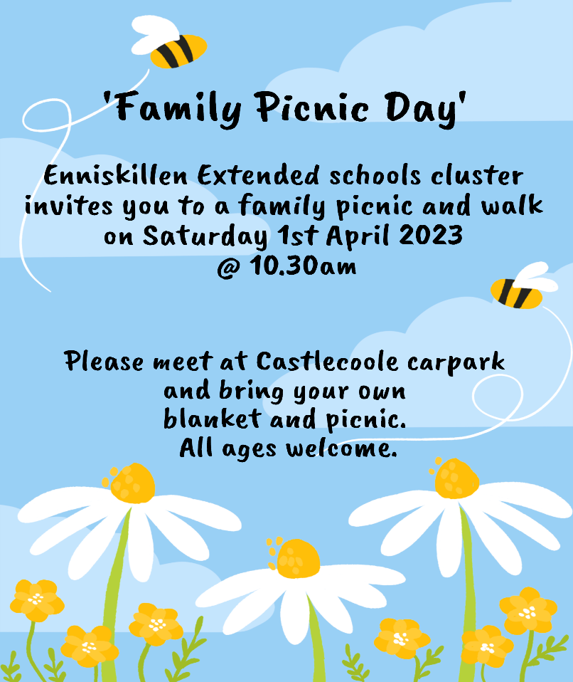
Family picnic: Saturday 1st April
Please come along and bring your family to this event ( weather permitting)
This is part of the funding that supplied the National Trust passes to each family and it is important that we show the value of these passes to secure future funding.

Easter trip to Castlecoole: Tuesday 4th April:
This will be the last day of term and children will receive an Easter pack home on this day of activities that you may find beneficial to develop skills in preparation for P1. Details to follow at a later date

School closures: Friday 17th March (St Patrick’s Day)
Last day of Term Tuesday 4th April
First day of term 3: Monday 17th April

