January Newsletter:
Happy New Year to you all and welcome back to a new term in school! We hope that the children will settle back into school quickly after all the excitement of Christmas, but it can be hard to readjust ( even for us as adults!). At home you can help by ensuring that your child gets back to a consistent bedtime routine as soon as possible and encouraging them by talking to them about all the exciting things we will learn in school this term.
January Topic: Winter/ Family
How can you help at home?:
- Talk to your child about different members of your family and how you are all connected.
- Talk about how they have grown and changed from a baby until now and what you think they will be like as they grow older
- Tell them the things that make them special and encourage them to talk to you about what they love about you
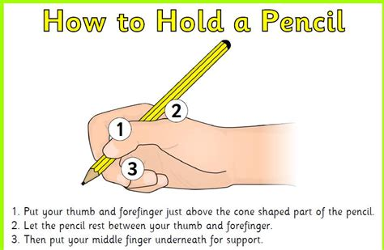
- Observe seasonal changes and spend time outdoors looking at what is happening in the world around them. Feed the birds, talk about looking after people/ animals etc in cold weather.
- Begin to encourage pincer grip when holding pencils, tools etc
- Encourage your child to focus/finish a task for a period of 5 minutes or more

Our Family:
We will be deepening the children’s understanding of ‘belonging’ this month through work on family and growing. We would ask that you send in a baby photo of your child (named on back) so that we can talk with them about how they have changed and grown.
We recognize that all families look different in their make up and we will be talking to the children about people who are special to them. We will be having a ‘Special People’ celebration at the end of our topic. This is an opportunity for your child to invite someone who is special to them into school. This can be grandparents, aunties, uncles, childminder or family friend… anyone who is special in their lives!
AM class: Friday 27th@ 11am
FT class: Friday 27th @ 1pm

Housekeeping:
Please send all Nursery Fund(£15) to school on the first school day of the month. This money pays for all activities, resources, treats and snacks that your child receives in school and we feel it offers great value for money. It is also school policy that staff do not handle cash, so all money coming into school ( apart from Breakfast Club) should be sent clearly labelled in the yellow envelopes provided. If you have run out or misplaced these please speak to a member of staff.

As we are now in the Winter months, can we ask you to check that all coats, scarves, hats etc are labelled clearly. Due to the weather children need to be changed more frequently, so please can you ensure that your child has adequate spare clothes in their school drawer(especially socks). You are welcome to come into school at the start or end of the session to check your child’s drawer.

Big Bedtime Read:
There are still a number of book bags outstanding. Please could these be returned as soon a possible.

Junk materials:
We are looking for toilet roll and kitchen rolls tubes for craft and construction. We would love donations of empty thread spools, metal washers, corks, ribbons and wrapping paper if anyone is having a clear out. Also, if anyone has any old hats/fascinators, old glasses frames, handbags or purses that they would like to donate to our dressing up collection we would be most grateful.

National trust passes:
Due to absence before Christmas a number of families have not yet received their National Trust passes. Please see a member of staff if you have not yet received one.

School Applications:
The School Application Portal at www.eani.org.uk opens on 10th January and closes again on 27th January. You will need to make an application for your child’s P1 place. If you have not visited any schools or are unsure of where to send your child can I encourage you to make contact with local schools who will be very happy to talk with you and assist you.
If you have any children at home, born between 2 July 2019 and 1 July 2020 they will be due for preschool in September 2023 and will need to make an application via the portal for this. Please speak to Mrs Phair who will be able to assist you with this.
We may also have limited places for children born after 2 July 2020 in our afternoon session. Again, please contact Mrs Phair.
Our final ‘Peek and Play’ session for new preschool pupils will be on Saturday 14th January from 10am-11am and we encourage you to spread the word to others about this. Our school depends on the good word of parents who have had a positive experience with us and we ask that you help us by telling others what we have to offer preschoolers in the area.

We will be meeting with you again later in the term to chat about your child, but in the meantime, if you have any questions or queries please feel free to get in touch at any time.
Kind regards,
Lisa Phair
Principal

