December update (preschool):

Monthly Topic: Christmas and celebrations
How can you help at home?
- Talk to your child about the Nativity Story. Can they tell you what happened? Sing the songs with them at home and talk about dressing up/putting on a show
- We are focusing on scissor skills in school this month: please give your child opportunities to practice at home
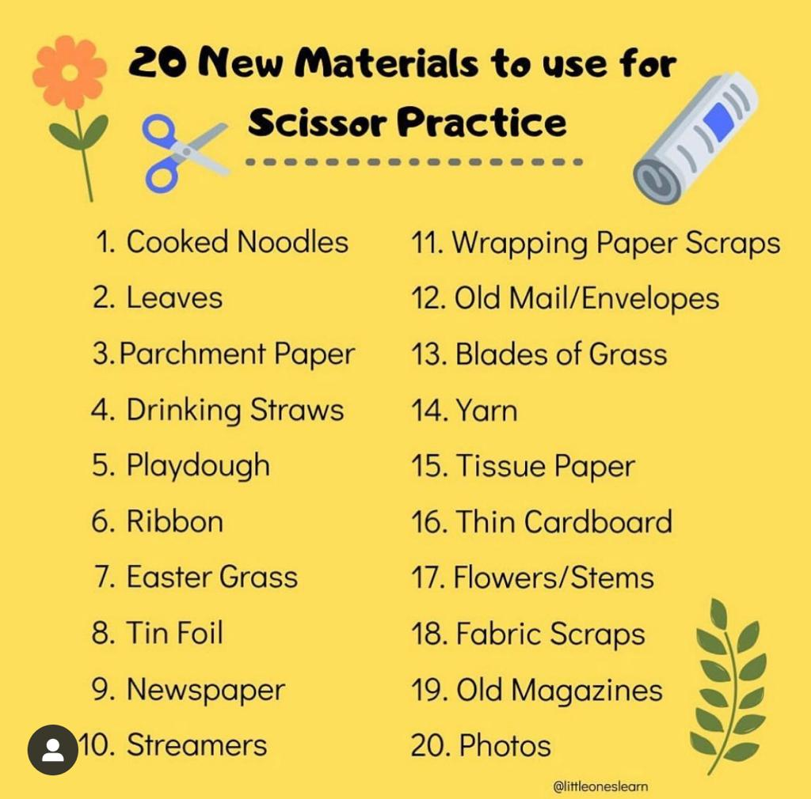

- Increase your child’s awareness of patterns: talk about patterns on wrapping paper, scarves, decorations, lights etc.

Christmas Nativity Play:
AM class: Wednesday at 10.30am. Parents can arrive from 10am (please use front door) for tea/coffee and mince pies. All children will go home with a grown up after the show. NO SCHOOL FOR FT CLASS ON THIS DAY
FT class: Thursday at 10.30am. Parents can arrive from 10am (please use front door) for tea/coffee and mince pies. All children will go home with a grown up after the show. NO SCHOOL FOR AM CLASS ON THIS DAY.

At the moment, we have children off school with Chicken Pox, scarlet fever and a vomiting bug. If your child is unwell, we ask that you do not send them into school. We appreciate that it is a great disappointment for parents if their child is unable to take part in the show, HOWEVER, it is not the same disappointment for your child. At this age, children have very little understanding of what it is to perform in a show and in fact, for many, this is something they will find extremely daunting. The achievement for each child is that they have learnt the songs and have a great understanding of why we celebrate Christmas. You will have many years to come watching your child perform in school plays etc and we ask at this time that you are mindful of spreading illnesses to both children and staff in the run up to Christmas.

Reminder: donations will be taken on both Nativity Play mornings towards The NI Ambulance service and the Royal Children’s Hospital in Belfast.

Christmas Jumper Day: Friday 9th December

Ardhowen Café Trip:
If you are free to join us to walk with the children, please let a member of staff know
FT class: Friday 9th, leaving school at 10.15am
AM class: Tuesday 13th leaving school at 9.45am

Model PS Christmas show:
Children in both AM and FT class will be walking across to the Model PS on Monday 12th to watch their school show and have snack in the school.

Big Bedtime Read Night;
Thursday 15th 6.30-7.30: children can come to school in their PJ’s for some supper and a treat. Children must be accompanied by an adult and staff are not responsible for children on this night.

Christmas party:
Wednesday 21st: children can come dressed in party clothes. School will finish for all children at 11.45 am on this day

Finally, can I take the opportunity on behalf of all the staff to wish you a happy, healthy and peace filled Christmas time. The greatest present you can give your child this year is your presence! Enjoy time with them, snuggle up with them and talk to them. Children will not remember what was under the Christmas tree this year when they look back, but they will remember the memories of time spent together with the people they love.
We look forward to working together with you in 2023
Mrs Phair and all the staff of Enniskillen Nursery School.

