January Newsletter:
Happy New Year to you all and welcome back to a new term in school! We hope that the children will settle back quickly after all the excitement of Christmas, but it can be hard to readjust (even for us as adults!). At home you can help by ensuring that your child gets back to a consistent bedtime routine as soon as possible and encourage them by talking about all the exciting things they will learn in school this term.
January Topic: Winter/ Family
How can you help at home?:
- Talk to your child about different members of your family and how you are all connected.
- Talk about how they have grown and changed from a baby until now and what you think they will be like as they grow older
- Tell them the things that make them special and encourage them to talk to you about what they love about you
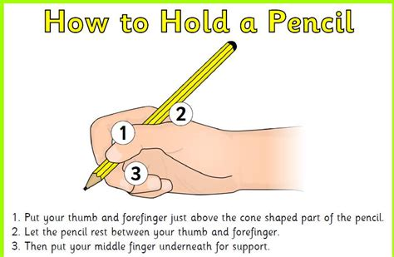
- Observe seasonal changes and spend time outdoors looking at what is happening in the world around them. Feed the birds, talk about looking after people/ animals etc in cold weather.
- Begin to encourage pincer grip when holding pencils, tools etc
- Encourage your child to focus/finish a task for a period of 5 minutes or more
- Scissor skill practice:

Our Family:
We will be deepening the children’s understanding of ‘belonging’ this month through work on family and growing. We would ask that you send in a baby photo of your child (named on back) so that we can talk with them about how they have changed and grown.
We recognize that all families look different in their make up and we will be talking to the children about people who are special to them. We will be having a ‘Special People’ celebration at the end of our topic. This is an opportunity for your child to invite one person who is special to them into school. This can be grandparents, aunties, uncles, childminder or family friend… anyone who is special in their lives!
AM class: Friday 26th@ 11am PM class: Friday 26th @2.30pm
FT class: Friday 26th @ 1pm

Housekeeping:
Please send all Nursery Fund(£15) to school on the first school day of the month. This money pays for all activities, resources, treats and snacks that your child receives in school and we feel it offers great value for money. It is also school policy that staff do not handle cash, so all money coming into school ( apart from Breakfast Club) should be sent clearly labelled in the yellow envelopes provided. If you have run out or misplaced these please speak to a member of staff.

As we are now in the Winter months, can we ask you to check that all coats, scarves, hats etc are labelled clearly. Due to the weather children need to be changed more frequently, so please can you ensure that your child has adequate spare clothes in their school drawer(especially socks). You are welcome to come into school at the start or end of the session to check your child’s drawer.
We are completely out of school stock of spare trousers and socks. If your child has gone home in something that belongs to school please can you return this. Also, if you have any spares that you would be happy to donate to school stock we would very much appreciate them.

Big Bedtime Read:
There are still a number of book bags outstanding. Please could these be returned as soon as possible.

Junk materials:
We have a store room completely filled with junk materials for the children to use. Thank you for this! We would ask that you do not send anymore until further notice.

Strike Date 18th January 2024:
Official confirmation was received yesterday of a planned full day strike by all workers in education, health and transport on Thursday 18th. At this point, please assume that school will not be open for children on this date. However, we remain hopeful that there may be a resolution to this dispute and if circumstances change we will inform you.

School Applications:
The School Application Portal at www.eani.org.uk opens TODAY 9thJanuary and closes again on 26th January. You will need to make an application for your child’s P1 place. If you have not visited any schools or are unsure of where to send your child can I encourage you to make contact with local schools who will be very happy to talk with you and assist you.
If you have any children at home, born between 2 July 2020 and 1 July 2021 they will be due for preschool in September 2024 and will need to make an application via the portal for this. Please speak to Mrs Phair who will be able to assist you with this.
We may also have limited places for children born after 2 July 2021 in our afternoon session. Again, please contact Mrs Phair.

We will be meeting with you again later in the term to chat about your child, but in the meantime, if you have any questions or queries, please feel free to get in touch at any time.
Kind regards,
Lisa Phair
Principal

