Home lending Term Three:
With the relaxation of covid measures in schools we would like to re-introduce our home/ school learning this term.
Each Thursday your child will receive home a school bag with a resource in it for you to enjoy together at home.
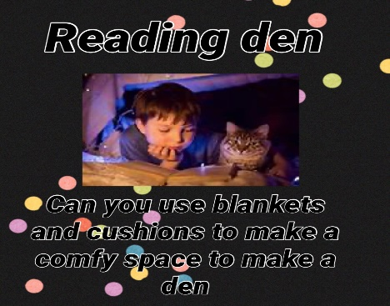
The activities included in the pack will give you the opportunity to join with your child in reinforcing a skill we have been developing with them in school.
The bags will include some of the following each week:
A library book: an opportunity to share and enjoy reading together. Research evidence has overwhelmingly shown that children who are read to regularly will attain higher levels of achievement across all areas of learning. Perhaps even more powerful though, is the evidence of a better sense of well being and security that these children are reported to have. Our children love stories in school and enjoy books that offer repetition as it allows them to become an active part of the reading. Talk to your child about what is happening in the pictures and encourage them to predict what might happen

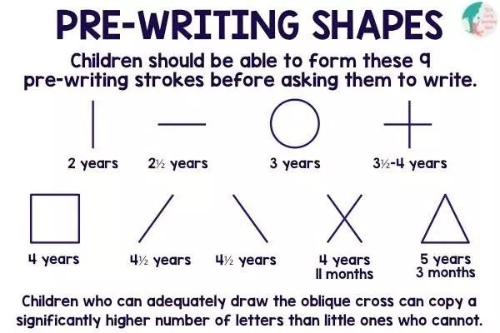
Whiteboard and pen: children are encouraged to develop a tripod grip as early as possible. Your child may not yet have decided which hand they will use to write with and this is ok. Let your child take the lead on this and find what is most natural for them. Some children will begin to form letters and others may make marks. Remember it is the process that is important and not the outcome and all children will develop in their own time. The focus is on encouraging them to try and to view writing/ mark making as appositive experience.

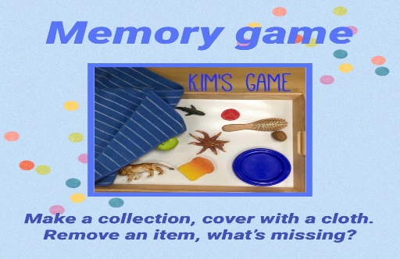
Snap cards: these activities are useful in so many ways developing your child’s understanding of turn taking and waiting as well as developing visual memory. These games can be used in different ways such as ‘pairs’ to develop skills further. Games such as this focus on the social aspect of learning which will be crucial for your child as they progress through school as building resilience as they accept that sometimes you win and sometimes you don’t!

Cutting skills: you have already received a pair of scissors in your home learning pack and children should be encouraged to use these often. They will really enjoy cutting pictures from old magazines and catalogues and this is a great rainy day activity!
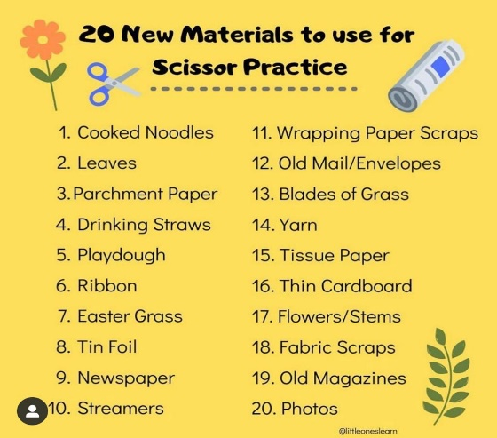
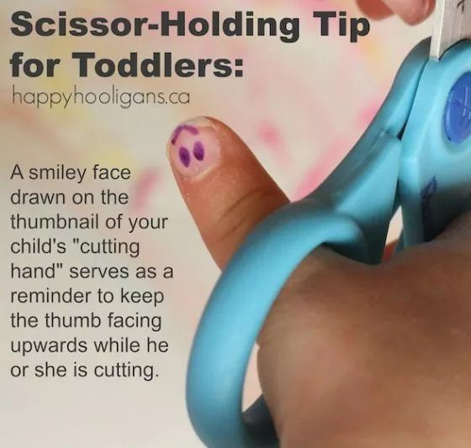

Each of these bags should be returned complete to school on Monday mornings. Please look after these packs as they are costly and if they are not returned we will not be able to lend these resources.

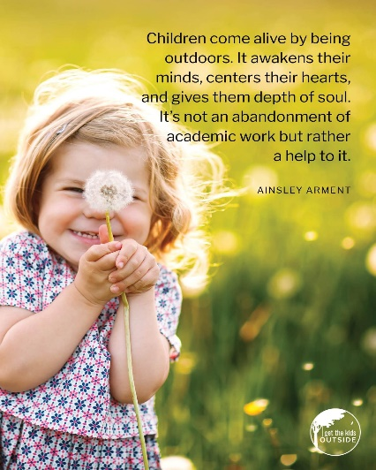
Outdoor play pack: the value of outdoor play in developing children’s gross motor skills cannot be underestimated. On week of 16th May your child will receive an outdoor learning pack. THIS IS FOR YOUR CHILD TO KEEP AT HOME.
This pack has been funded through the Getting Ready to Learn project and will contain a ball, skipping rope and some ground chalk. We hope you can take some time with your child to practice simple activities such as throwing and catching and helping them learn to skip. The challenge of this will be surpassed by the sense of success and accomplishment they will gain when they master these skills!

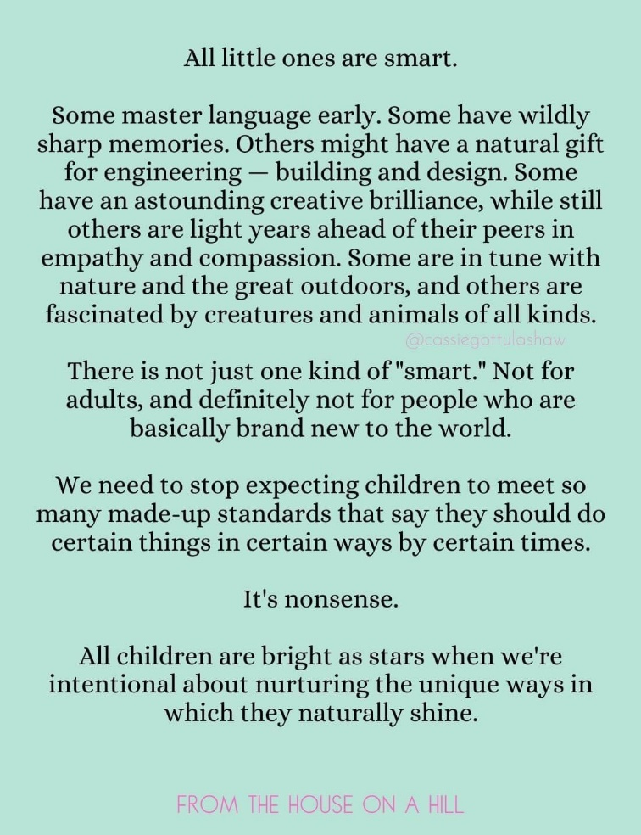

Above all, remember that our job as educators is to encourage and inspire. Children will all progress at different rates and it is important to remember that education is a journey not a destination, we are developing lifelong learners.
The focus in these activities is preparing your child for the next stage of their school adventure!

If you would like any further advice or guidance please contact me at school.
Regards,
Mrs Phair

